Task for the day:

Requirements :

* Make sure you have python running on your system, You can download python from the below site <https://www.python.org/downloads/>
* Need to have Mediainfo software, you can download this from <https://mediaarea.net/en/MediaInfo/Download>
* Basic knowledge of how mediainfo works
* Any proper video with duration of atleast 4 to 5 minutes.

Question:

Extract the data of the given video and get the details of it based on the inputs provided

Sample Input :

Python file : extractData.py

Video file : Sample.mp4

Input : Video

Execution – python extractData.py sample.mp4 Video

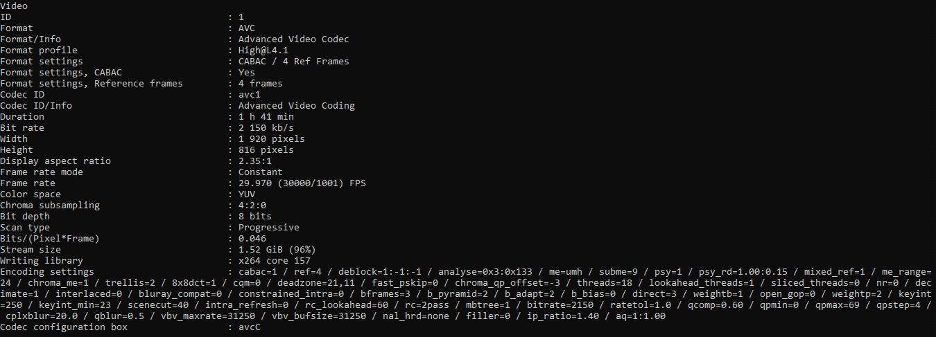Sample Output :

Note : After finishing this task there will be a continuation on this to extract Bitrate / incode /outcode

So don’t delete or uninstall any of the required files